A000-Eur-Viking-Pendant-Jellinge Style-Silver-900 CE

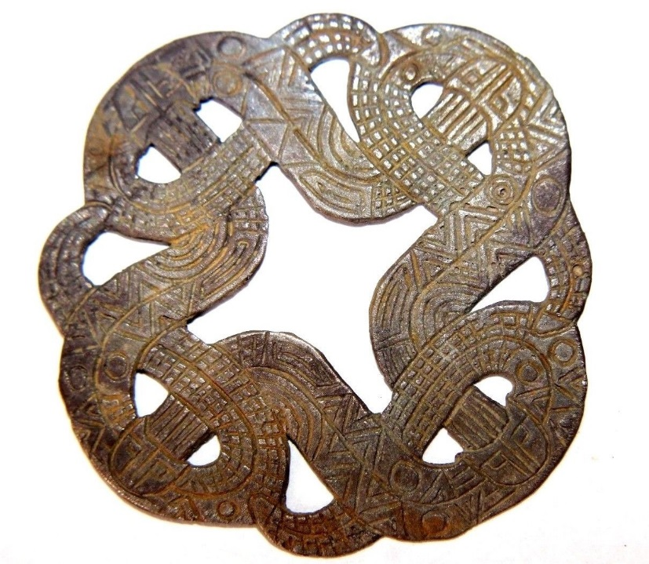 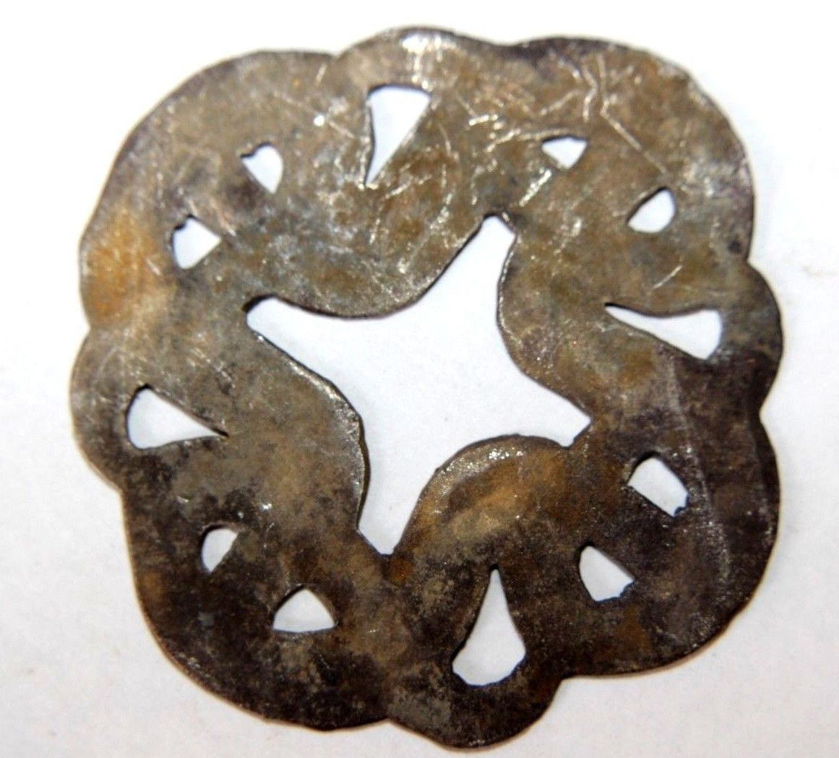

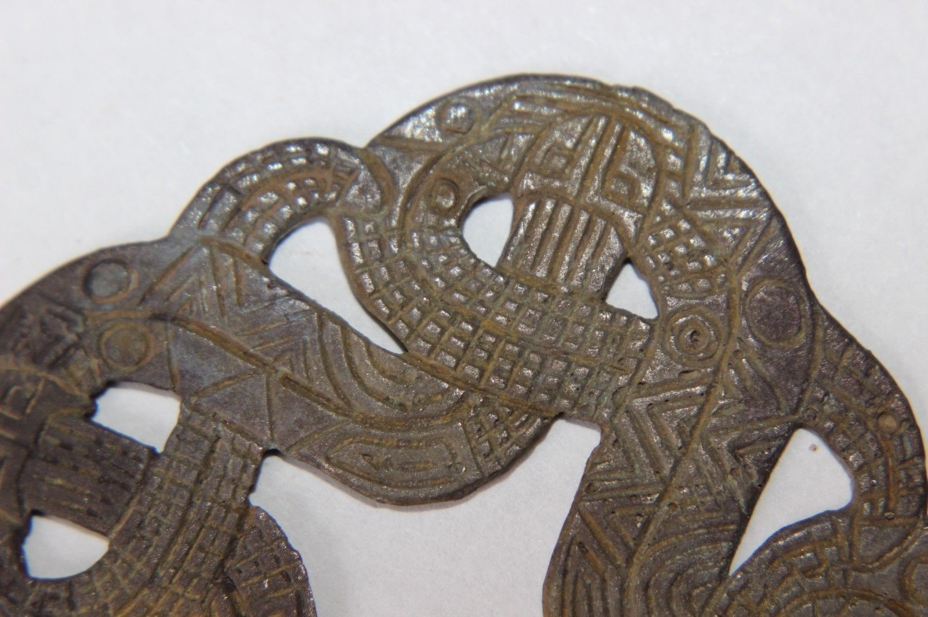

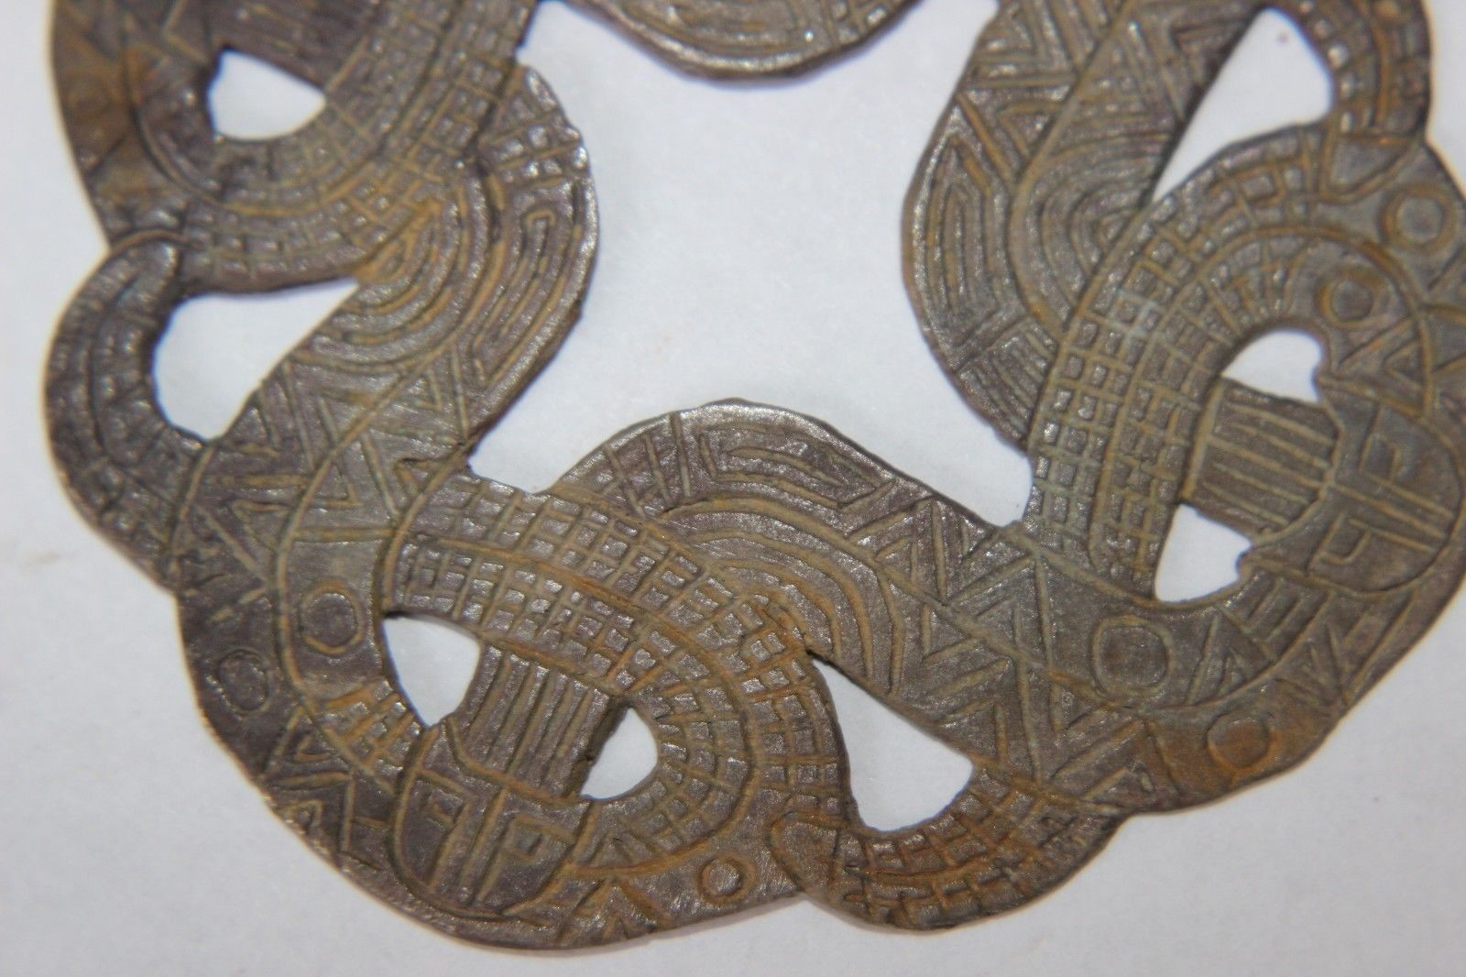

**Case No.: 4**

**Accession No.**

**Formal Label:**

**Display Description:**

The Jellinge style is from the X century and, unlike the first two. includes findings that are very diverse in geography, quality and motifs, which makes it difficult to define it precisely. Its main characteristic feature is angular interlaced ribbon-like animals with heads in profile, disproportionately short limbs, and spiral hips. Their ribbon­-shaped bodies are double­-contoured and filled with transverse billets.  
  
Source: <https://armstreet.com/news/the-viking-ornaments-six-major-styles>

**Accession Number:**

**LC Classification:**

**Date or Time Horizon:**

**Geographical Area:**

**Map:**

**GPS coordinates:**

**Cultural Affiliation:**

**Medium:** Silver

**Dimensions:** 55 mm

**Weight: 10.10 gm**

**Condition: original**

**Provenance:** old

**Discussion:**

**References:**